**UNIT V**

**Industrial Designs:** Eligibility Criteria. Acts and Laws to Govern Industrial Designs. Design Rights. Enforcement of Design Rights. Non-Protectable Industrial Designs India. Protection Term. Procedure for Registration of Industrial Designs. Prior Art Search. Application for Registration. Duration of the Registration of a Design. Importance of Design Registration. Cancellation of the Registered Design. Application Forms. Classification of Industrial Designs. Designs Registration Trend in India. International Treaties. Famous Case Law: Apple Inc. vs. Samsung Electronics Co

**About Industrial Designs**

The word ‘Design’ is defined as the features of shape, configuration, pattern, ornament or composition of lines or colours applied to any article. The Design may be of any dimension i.e. one or two or three dimensional or a combination of these. In addition, it may be created by any industrial process or means, whether manual, mechanical or chemical, separate, or combined, which in the finished article appeal to and is judged solely by the eye. But the word ‘Design’ does not include any mode or principle of construction or anything which is in substance a merely mechanical device. The main object of registration of **industrial Designs** is to protect and **incentivize the original creativity** of the originator and **encourage others to work** towards the **art of creativity.**

**5.1 Eligibility Criteria**

The Design for which the protection is being sought must be novel or original i.e., should not be disclosed to the public by prior publication or by prior use or in any other way. The Design should be significantly distinguishable from the already registered Designs existing in the public domain.

**5.2 Acts and Laws to Govern Industrial Designs**

In India, Industrial Designs are governed under ‘The Designs Act ‘, 2000 and ‘Design Rules ‘, 2001 which have been amended from time to time in 2008, 2013, 2014 and 2019. The Design should include the following characteristics:

* It should be novel and original.
* It should be applicable to a functional article.
* It should be visible on a finished article.
* There should be no prior publication or disclosure of the Design.

***Some of the famous Industrial Designs are mentioned below:***

**Coca-Cola Bottle** - The contoured-shaped glass bottle of the CocaCola Company is marvelled as a master showpiece in the field of industrial design. It was designed in 1915 and is still a cynosure for all eyes.

**Piaggio Vespa** - Piaggio is an Italian company famous for manufacturing Vespa scooters. These scooters are sold worldwide since 1940s. The structural design of the scooter is pleasing to the eyes. This two-wheeler has a painted steel body concealing the engine, driver‘s feet rest comfortably on a flat floorboard, the front vertical portion comprising of a handle, breaks and speedometer has ample space for hands‘ grip and also provides protection from incoming wind air.

**iPhone** - It is a highly popular mobile phone manufactured by American company ‗Apple Inc‘. The sleek, handy and rectangular body is pleasing to the eyes. The corners are round and smooth. The features, such as on/off and speech volume, are easy to operate.

**Mini Cooper** - Mini Cooper is an automobile car manufactured by the British Motor Corporation in the later part of the 20th century. It is a small size car. Its shape has been designed in a unique manner so as to provide plenty of space (nearly 80%) for passenger seating and luggage storage.

**Rocking Wheel Chair** - It is a sleek, circular-shaped chair which provides smooth rocking motion. There is a provision for a headlight in the upper part of the chair.

**Juicy Salif** - It is a citrus juice squeezer and considered an iconic structural design. The alumina-based body has been moulded in the shape of a fish called as a squid.

**5.3 Design Rights**

The Design registration also confers a monopolistic right to the Proprietor by which he can legally exclude others from reproducing, manufacturing, selling, or dealing in the said registered Design without his prior consent. The Design registration is particularly useful for entities where the shape of the product has aesthetic value and the entity wishes to have exclusivity over the said novel and original Design applied to its product(s) or article(s).

**5.4 Enforcement of Design Rights**

Once the applicant has been conferred with the rights over a specific Design, he has the right to sue the person (natural/entity) if the pirated products of his registered design are being used. He can file the infringement case in the court (not lower than District Court) in order to stop such exploitation and for claiming any damage to which the registered proprietor is legally entitled. The court will ensure first that the Design of the said product is registered under the Designs Act, 2000. If the Design is found not registered under the Act, there will not be legal action against the infringer. If the infringer is found guilty of piracy or infringement, the court can ask him to pay the damage (₹ 50,000/-) in respect of infringement of one registered Design.

**5.5 Non-Protectable Industrial Designs in India**

* Any Industrial Design which is against public moral values.
* Industrial Designs including flags, emblems or signs of any country
* Industrial Designs of integrated circuits.
* Any Design describing the ‘process of making of an article’.
* Industrial Designs of – books, calendars, certificates, forms and other documents, dressmaking patterns, greeting cards, leaflets, maps and plan cards, postcards, stamps, medals.
* The artistic work defined under Section 2(c) of the Copyright Act, 1957 is not a subject matter for registration for Industrial
* Designs, such as:
  1. Paintings, sculptures, drawings including a diagram, map, chart or plan.
  2. Photographs and work of architecture.
  3. Any other work related to artistic craftsmanship.
* Industrial Designs does not include any Trademark (The Designs Act, 2000).

**5.6 Protection Term**

* The outer ‘Shape or Design’ of a product makes it more appealing and acts as the value-adding factor to the product.
* Therefore, there is a need to protect one ‘s creation from being used by third parties’ without consent from the original creator.
* The registered Designs are protected for 10 years in India and can be extended by 5 years after making a renewal application.

**5.7 Procedure for Registration of Industrial Designs**

**5.7.1 Prior Art Search**

Before filing an application for registration of Industrial Designs, it is prudent to ensure that the

same or similar Design has not been registered earlier. This search can be carried out using various search engines, such as:

* Design Search Utility (CGPDTM) (https://ipindiaservices.gov.in/designsearch/).
* Global Design Database (WIPO) (https://www3.wipo.int/designdb/en/index.jsp).
* Hague Express Database (WIPO) (https://www3.wipo.int/designdb/hague/en/#).
* Design View (EUIPO) (https://www.tmdn.org/tmdsviewweb/welcome#/dsview).

**5.7.2 Application for Registration**

Once the applicant deems their design novel and distinct from others, they can proceed to file a Design registration application, which is open to individuals, small entities, institutions, organizations, and industries. Filing can be done through a professional patent agent or legal practitioner, with non-resident applicants requiring an agent in India. The application is submitted to the Deputy Controller of Patents & Designs at the Patent Office in Kolkata. Following submission, an examiner assesses the application, applying eligibility criteria. If queries arise, the applicant has six months to respond. Upon resolving objections, the application is accepted, and details are published in the Official Journal of the Patent Office. If no public objections are received, the design is registered, granting the applicant exclusive rights. The proprietor can request a certificate of registration, and a registration process flow chart is illustrated in Figure 5.1.

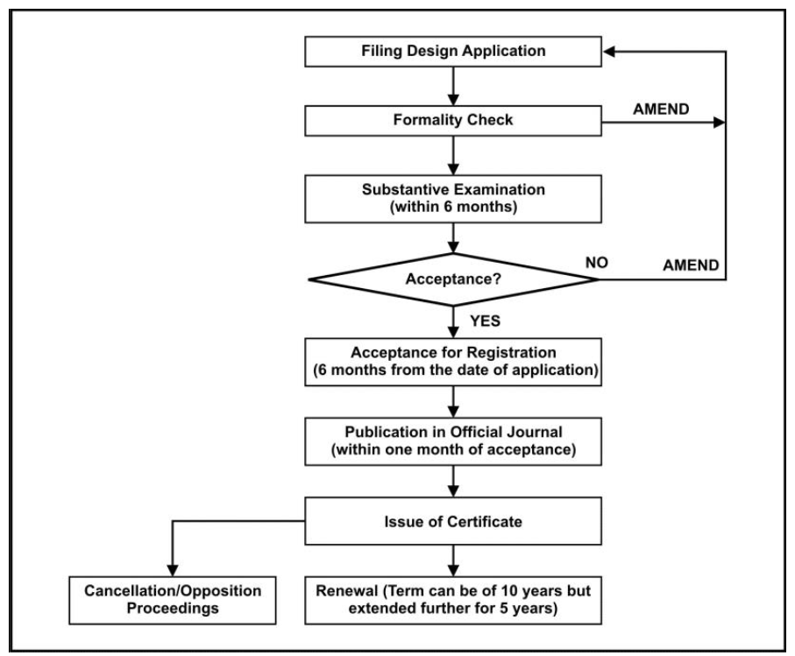

**Figure 5.1: Flowchart for the process of Design registration.**

**5.8 Duration of the Registration of a Design**

Initially, the Design registration is valid for ten years from the date of registration. In the case wherein the priority date has been claimed, the duration of the registration is counted from the priority date. The period of registration may be extended further for five years. An application has to be made in Form-3 accompanied by prescribed fees to the Controller General before the expiry of the said initial period of ten years.

**5.9 Importance of Design Registration**

Registration of Design ensures the exclusive rights of the applicant on the Design. The owner can prevent the registered Design products from piracy and imitation. This helps the owner to boost the sale of the products and establish goodwill in the market.

**5.10 Cancellation of the Registered Design**

The registration of a Design may be cancelled at any time. The petition has to be filed in Form-8 with prescribed fee to the Controller of Designs. The application can be made on the following grounds:

* Design has already been registered.
* Design has been published in India or elsewhere before the date of registration.
* Design is not novel and original.
* It is not a Design under Clause (d) of Section 2

**5.11 Application Forms**

There are a total of 24 forms pertaining to Industrial Designs. A list of important forms is mentioned below.

**Table 5.1: List of important form related to Industrial Designs.**

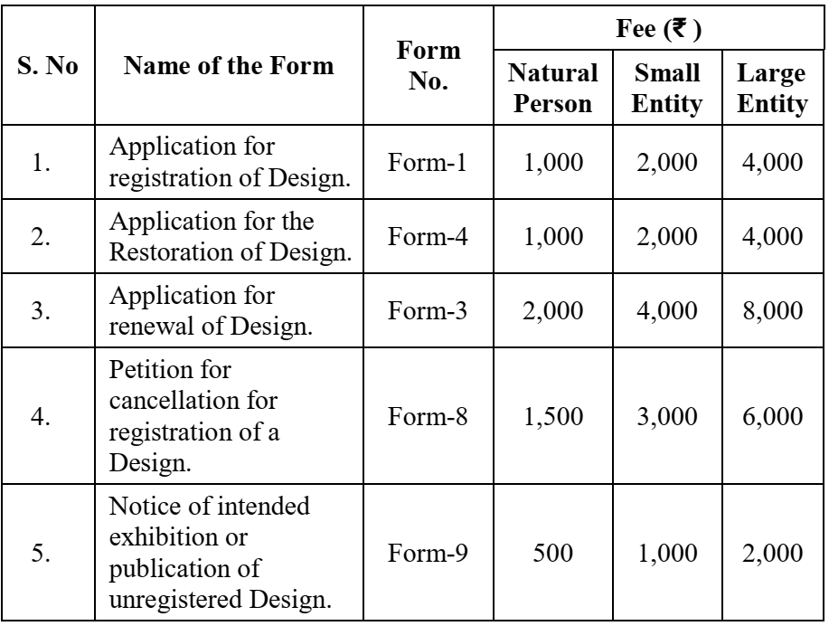

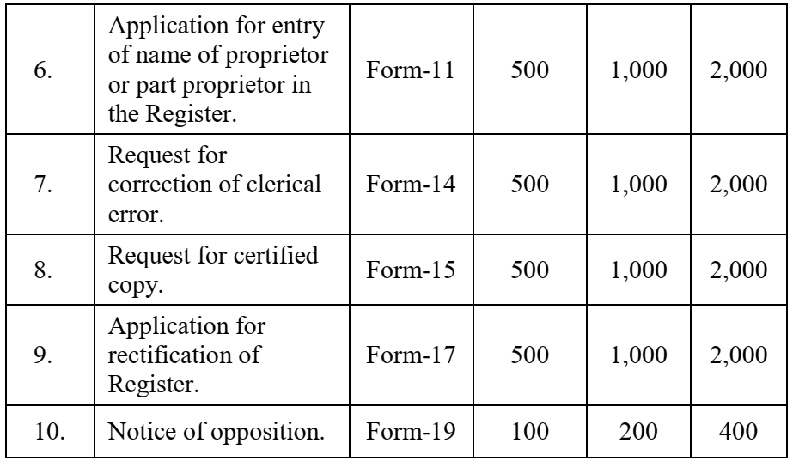

**5.12 Classification of Industrial Designs**

* Designs are registered in different classes as per the Locarno Agreement, 1968;
* It is used to classify goods for the registration of Industrial Designs as well as for Design searches.
* The signatory parties have to indicate these classes in the official documents too.
* The classification comprises a list of classes and subclasses with a list of goods that constitute Industrial Designs.
* There are 32 classes and 237 subclasses that can be searched in two languages i.e. English and French.
* For example, Class 1 includes foodstuff for human beings, foodstuffs for animals and dietetic foods excluding packages because they are classified under Class 9 (Bottles, Flasks, Pots, Carboys, Demijohns, and Pressurized Containers). Class 32 classifies the Design of graphic symbols and logos, surface patterns, ornamentation.

**5.13 Designs Registration Trend in India**

Figure 5.2 represents the statistics for Industrial Designs (filed, examined and registered) for the period 2010-20. During this period, an increase of 88%, 117% and 33% was observed in the parameters of Designs filed, examined and registered, respectively. In all three parameters, the graph depicts a similar pattern (more or less) with the highest numbers observed in 2019-20 for Designs filed (12,268), examined (13,644) and registered (14,272)

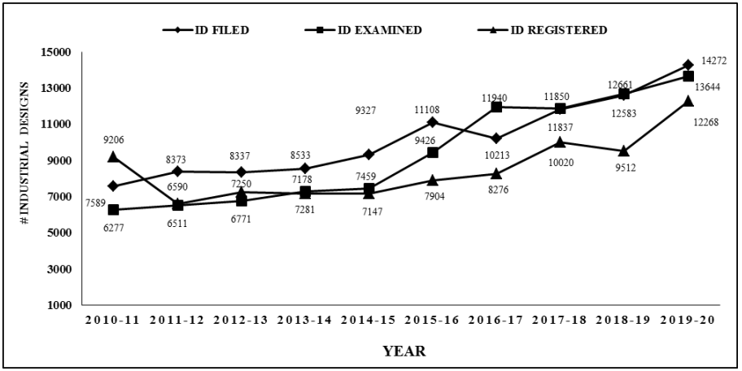

**Figure 5.2: Industrial Designs profile (India) for the period 2010-20).**

**5.14 International Treaties**

The WIPO has put in place two important treaties (international) dealing with the smooth functioning of various aspects of Industrial Designs:

* Hague Agreement for international registration (1925) (https://www.wipo.int/treaties/en/registration/hague/)
* Locarno Agreement (1968) for international classification (https://www.wipo.int/treaties/en/classification/locarno/)

**5.15 Famous Case Law:**

***Apple Inc. vs. Samsung Electronics Co.***

In 2011, Apple Inc. filed a case against Samsung Electronics Co. in the United States District Court for the Northern District of California for infringing their Designs and Utility Patents of the user interface like screen app grid and tap to zoom. As evidence, Apple Inc. submitted the side-by-side image comparison of the iPhone 3GS and the i9000 Galaxy S to demonstrate the alleged similarities in both models. However, later it was found that the images were tempered by the Apple Company to match the dimensions and features of the controversial Designs. So the counsel for Samsung Electronics blamed Apple of submitting false and misleading evidence to the court and the company countersued the Apple Company in Seoul, South Korea; Tokyo, Japan; and Mannheim, Germany, United States District Court for the District of Delaware, and with the United States International Trade Commission (ITC) in Washington D.C. The proceedings continued for the 7 years in various courts. In June 2018 both companies reached for a settlement and Samsung was ordered to pay $539 million to Apple Inc. for infringing on its patents.